**Lab Report:** Setting Up Python Environment and Introduction to Core Libraries for Machine Learning



**UET PESHAWAR**

**(JALOZAI CAMPUS)**

**ARSALAN TAHIR (21JZELE0426) SEMESTER: 8th DEPARTMENT: ELECTRICAL**

**LAB: Machine Learning Lab 01**

# Objective:

The objective of this lab was to establish a functional Python development environment and gain foundational knowledge of Python programming concepts, along with an introduction to essential machine learning libraries such as NumPy and Pandas.

# Tasks Performed:

1. Set up Python and Jupyter Notebook as the primary tools for data-driven development.
2. Installed Visual Studio Code (VS Code) to enable efficient code editing and project management.
3. Created and configured a virtual environment to ensure isolation and reproducibility of machine learning workflows.
4. Gained foundational understanding of Python programming concepts, including variables, data types, control structures, and functions.
5. Introduced and practiced using core machine learning libraries such as NumPy for numerical computation and Pandas for data manipulation and preprocessing.

# Tools and Platforms Used:

1. Python: Core programming language used for scripting and development. <https://www.python.org/downloads/>
2. Anaconda Distribution (Optional): A comprehensive platform for scientific computing, including package management and environment setup. <https://www.anaconda.com/download>
3. Visual Studio Code (VS Code): A powerful and lightweight source code editor used for writing, debugging, and managing Python code. <https://code.visualstudio.com/>
4. Jupyter Notebook: An interactive environment for writing and running code, particularly useful for data analysis and visualization (available via Anaconda or as a standalone tool).
5. Google Colab: A cloud-based platform that allows execution of Python code in a browser without local installation. <https://colab.research.google.com/>

# Environment Setup Screenshot:

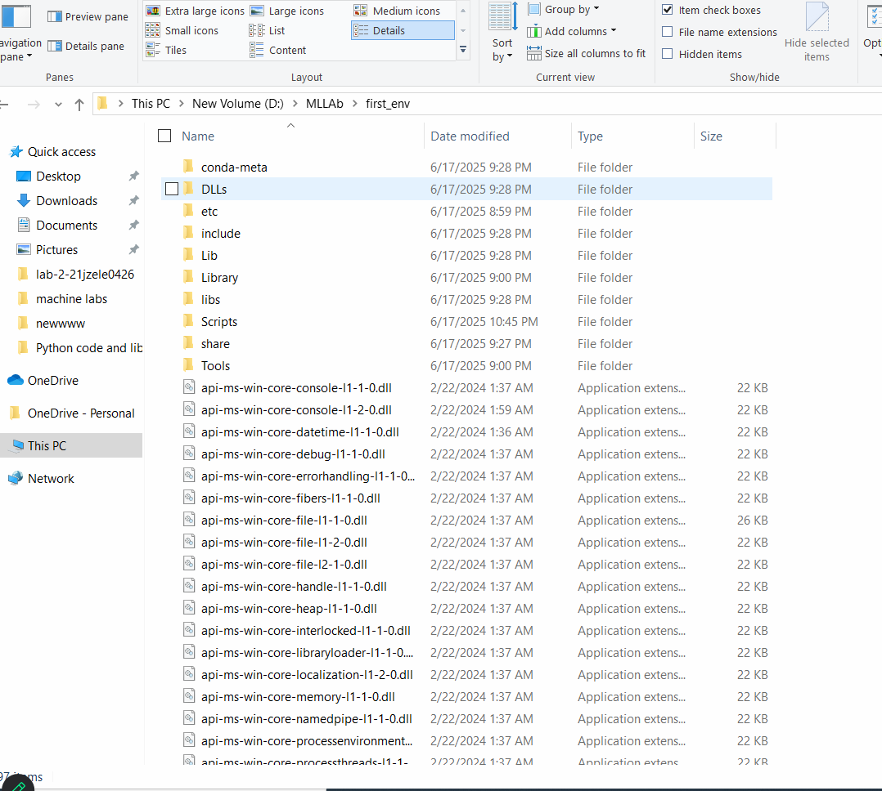

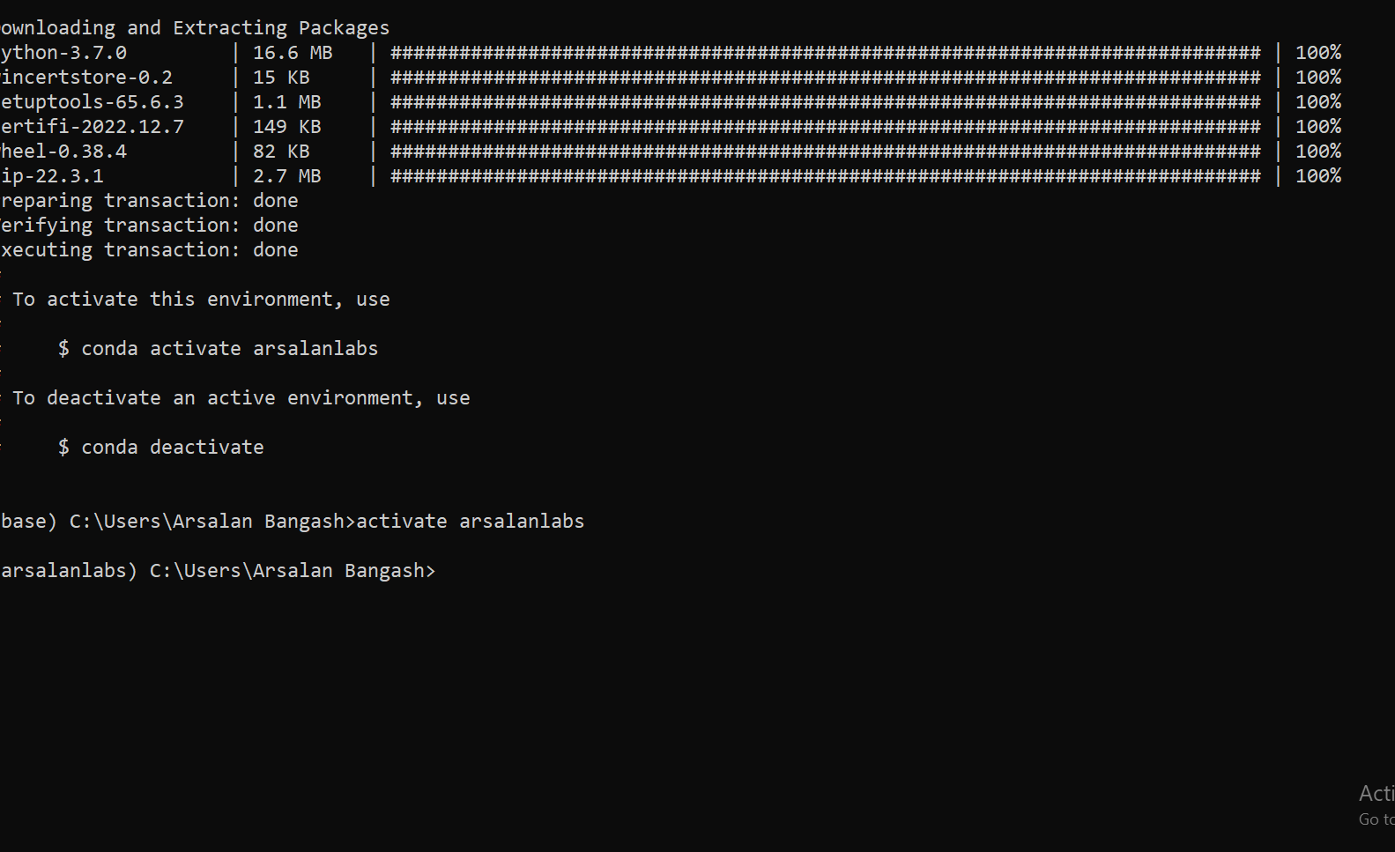

**Python Libraries Explored:**

1. NumPy: A fundamental library for numerical computing in Python, used for handling arrays, mathematical operations, and linear algebra.
2. Pandas: A powerful library for data manipulation and analysis, providing data structures such as Series and DataFrames for structured data.
3. Matplotlib & Seaborn: Libraries used for data visualization, enabling clear and insightful graphical representation of data.
4. Scikit-learn: A widely used machine learning library that provides simple and efficient tools for data mining, classification, regression, and clustering.
5. TensorFlow (Introduction): An open-source library for numerical computation and large-scale machine learning, with a focus on deep learning workflows.
6. Keras (Introduction): A high-level neural networks API, integrated with TensorFlow, used for building and training deep learning models.

**Learning Resources:**

1. Stack Overflow (<https://stackoverflow.com/>): A community-driven platform for troubleshooting programming issues, asking questions, and finding solutions to common Python and machine learning problems.
2. Real Python (<https://realpython.com/>): A comprehensive resource offering tutorials, articles, and videos tailored to Python developers of all levels.
3. YouTube Channels:
4. Real Python: High-quality tutorials covering core Python concepts and advanced techniques.
5. StatQuest: Simplifies complex machine learning and statistical concepts using intuitive explanations.
6. GitHub (<https://github.com/>): A version control and collaboration platform widely used to access, share, and manage code repositories for Python and machine learning projects.
7. Coursera – Machine Learning by Andrew Ng (<https://www.coursera.org/specializations/machine-learning-introduction>): A foundational course for understanding key machine learning algorithms and their practical applications.
8. Machine Learning Mastery (<https://machinelearningmastery.com/>): A valuable blog and book resource focused on practical implementations of machine learning and deep learning techniques.
9. Google Colab Tutorials: Interactive notebooks and learning modules for hands- on experience with machine learning workflows in a cloud environment.

**Conclusion:**

This lab provided me with a solid foundation in setting up a Python development environment using tools like Jupyter Notebook, Visual Studio Code, and virtual environments. I gained hands-on experience with core Python programming concepts and explored essential libraries such as NumPy and Pandas for data manipulation and analysis. Additionally, I familiarized myself with valuable resources and platforms that support continuous learning in Python and machine learning. This initial setup and learning phase has equipped me with the necessary tools and knowledge to advance further into areas like Machine Learning, Deep Learning, and Data Science.